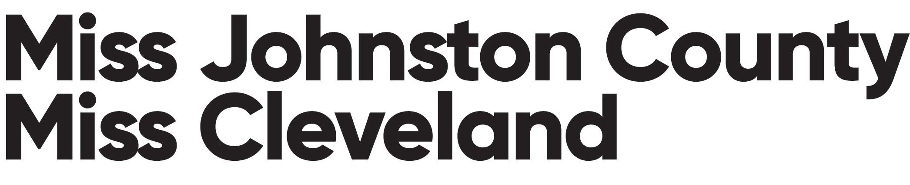

**AD SALES:**

**Program Books**

All candidates are *encouraged* to sell at least ONE full page ad for the program book.

* Ad pages are as follows:

**FULL PAGE: $150**

**HALF PAGE: $75**

**QUARTER PAGE: $50**

**BUSINESS CARD: $25**

*ALL CHECKS MUST BE PAYABLE TO THE JOHNSTON COUNTY SCHOLARSHIP ORGANIZATION WHICH IS A NON-PROFIT ORGANIZATION.*

**All AD pages must be submitted/emailed** *(*[*info@missjoco.org*](mailto:info@missjoco.org)*)* **to us by January 15, 2023 and paid in full by January 15, 2023 (NO EXCEPTIONS).**

* Ads must be printer ready.
* Full pages are 8.5 x 11
* No photos of ads will be accepted - must be original
* Please label ad info with candidate name in the email.

**Miss/Teen Candidate Name___________________________________________**

**Name of Business Ad size Amount Paid**

|  |  |  |
| --- | --- | --- |
|  |  |  |
|  |  |  |
|  |  |  |
|  |  |  |
|  |  |  |
|  |  |  |
|  |  |  |
|  |  |  |
|  |  |  |