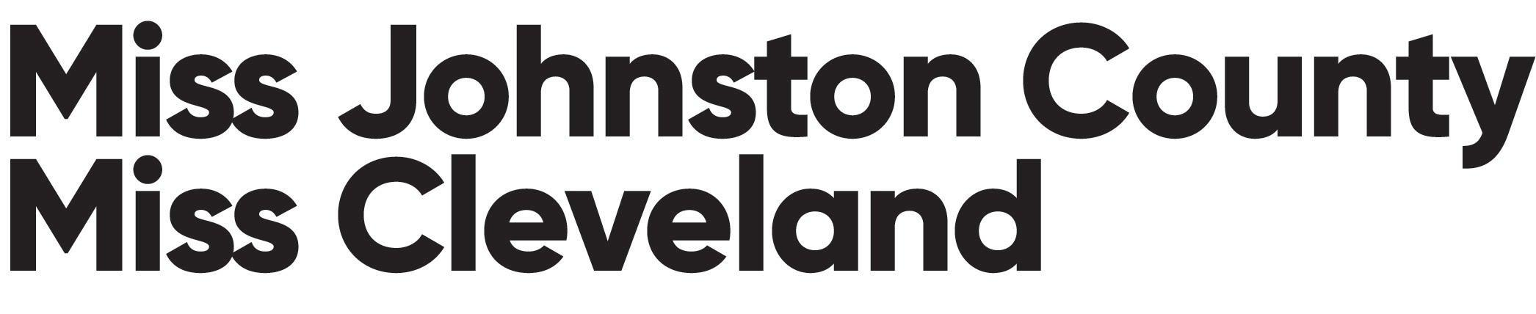

Silent Auction Baskets
We are asking each candidate to provide a basket for a silent auction during the evening of the Miss Johnston County/Miss Cleveland Competition. Each candidate should remember the following things in collecting items for their basket.
1) Make sure that you have all items displayed under plastic wrapping with no loose parts that could be lost or taken off.

2) Pack the basket as compactly as possible including a complete list of the items and value of each inside. Place your name and photo inside the basket so people know who put it together along with items in the basket and value. If you receive large items like furniture make sure they are marked with your name also.

3) Be creative with your basket. Items can include tickets to sporting or entertainment events. Jewelry is also a big hit. Think about what your area has to offer and talk to the local merchants and manufacturers about unique items. Theme gift baskets or gift bundles make great silent auction ideas.

Please bring your basket to dress rehearsal on Friday, January 27, 2023. We will have bidding forms for you. Thank you in advance for your forethought for making your basket.

